RPG Modeling http://www.secomgroup.com/articles44.php

A while back, a friend of mine was working on some code for a role-playing game that he was developing. In trying to constrain certain conditions, he had been trying to come up with solutions that involved very complicated polynomial functions. While the he found a solution that worked, it made a lot of assumptions about the input values and still wasn't behaving in the ideal way. After examining the problem myself, I found an astonishingly simple solution in a well-known but rarely used trigonometric function.
The Scenario
In this RPG, characters in battle were to have opposing skill levels. For example, the player currently attacking would have an offensive skill level and the player being attacked would have a defensive skill level. If these skills were equal, the odds of a successful hit were to be 50/50. If the offensive skill level was higher than the defensive skill level, the odds of a successful hit were to be greater and vice-versa.
Problem 1
It is possible to create any number of polynomial functions that would determine the percent of a hit based on the two opposing skill levels. However, this required an absolute maximum and minimum for each skill. This could be done, but didn't leave much room for growth in the game. It would be better to not assume such limits so that high level, immortal, or even god-like characters can always be added as the game expands.
Problem 2
One of the classic problems of RPGs is that beginning characters have virtually no chance of defeating more powerful characters. While avoiding such un-winnable fights has become part of the game, it isn't very realistic. After all, in real life even the worst of fighters has at least some chance to hit the most experienced and heavily armored of warriors.
A more realistic scenario would not be to allow any situation where either a hit or miss is automatic. Equal opposing skills should still be 50/50 odds, but no matter how this ratio changes, the odds should never be 100% or 0%. The odds can approach those values as closely as possible, but should never reach them. For those with a strong math background, this should be a hint that a typical polynomial function is not going to work!
Problem 3
In keeping with the idea of a balanced game, differences in opposing skills should not vary directly with the odds of a successful hit. Specifically, skill differences for skill levels that are close in value should make the greatest difference in percentages of success, but these percentages should eventually level off.
The idea for this particular RPG was to make sure that extreme differences in skill level did not result in odds too close to 0% or 100%. For example, a skill difference of 2 would have significantly higher odds of success than a skill difference of 1, but a skill difference of 1000 should have only slightly higher odds of success than a skill difference of 999.
A Description of the Desired Function
Let's review what we know about the function we want to find.
It's only going to have a single input variable (the difference in skill levels, where a positive value means the attacker's offensive skills are greater than the attackee's defensive skills). The output should be between 0 and 1 where 0 means the odds of success are 0% and 100% respectively. To avoid any unintended constraints, I'm going to assume that the skill difference can be any real number and not just integers within certain bounds. Additionally, we never want the values of 0 and 1 to be returned. Therefore, our function should map from the real numbers to the set of real numbers between (but not including) 0 and 1.
f : R --> (0, 1)
Since we are not limiting the input values of our function, the function must be continuous for all real numbers. It should more specifically be continuously increasing, so that larger input values result in larger output values. The output value should never reach 0 or 1, but the limits of our function at negative infinity and infinity should be 0 and 1, respectively.
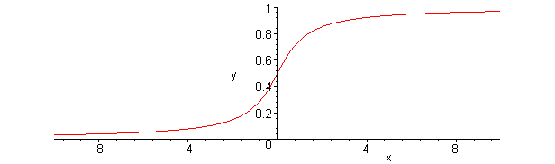
The greatest variations should occur when skill levels are equal, so the derivative of our function should be some specific number when the input is 0. This number is arbitrary, but can be used to \"scale\" the function later. Conversely, the derivative should approach 0 as the input value becomes arbitrarily large. This will help to \"flatten out\" our function at the edges. The number we use to scale this function later on will determine how quickly this happens.
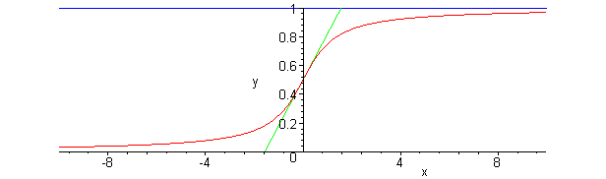
Defining the Desired Function
When trying to describe the desired behavior of this function, I noticed that it looked familiar to me. It resembled the behavior of the arctangent function, although the specific values varied. Arctangent is continuously increasing, has derivatives approaching 0 at the extremes, and has the greatest derivative at 0.
f(x) = arctan(x)
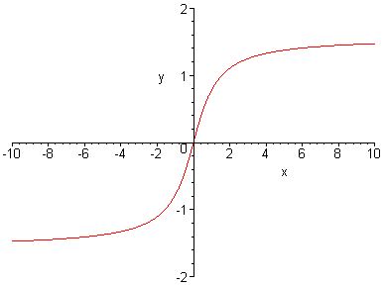
What we need to change first is the y-intercept of this function. Since a skill difference of 0 should result in 50/50 odds, the y-intercept should be 0.5.
f(x) = 0.5 + arctan(x)
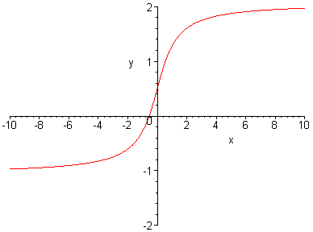
Next, we need to change the limits of our function. Since arctangent takes on a range of values between -π/2 to π/2, we need to divide by p. This may not be completely obvious at first but makes more sense once you see the graph.
f(x) = 0.5 + arctan(x) / π
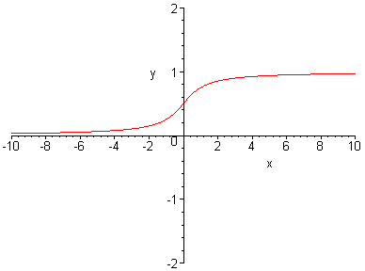
The last thing we need to do to our function is scale it. We can do with by multiplying the x by a constant. What constant we use depends on the programmer's needs. Here is an example.
f(x) = 0.5 + arctan(3x) / π
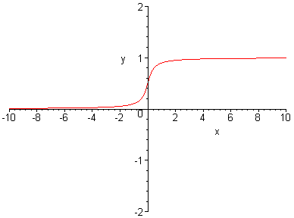
One really nice thing about using arctangent is that we could even use values that aren't constant for our scaling value, such as other skill levels or factors like mood, visibility, or initiative. No matter what we do inside the arctangent part of our function, our values will stay within the desired range.
Conclusion
While this is a very specific example of defining a function to match desired behaviors, there are a couple things to take from it. First, if you can at least find a function that looks something like what you need, you can always manipulate it to do what you want. The real trick is making sure you know what you need first.
Second, there is no need to reinvent the wheel. There are a lot of mathematical functions out there. If you find yourself creating some enormous function to do what you need, take a moment to look at the trigonometric, hyperbolic, and other functions already out there.

