MATH 300 Dataset

Individual | Major | Class | Hours Slept | Height | Enjoy math
1 | IE | 2 | 4.5 | 64 | 4
2 | IE | 2 | 6.5 | 65 | 4
3 | IE | 3 | 5 | 63 | 4
4 | IE | 1 | 8 | 68 | 5
5 | IE | 4 | 7 | 70 | 4
6 | IE | 2 | 6.5 | 68 | 4
7 | IE | 2 | 7 | 72 | 5
8 | CSCI | 3 | 7 | 71 | 3
9 | Education | 3 | 8 | 67 | 4
10 | Education | 4 | 8.5 | 64 | 4
11 | Math | 4 | 5.5 | 66 | 4
12 | Math | 2 | 6 | 66 | 4
13 | Math | 3 | 5 | 63 | 5
14 | MathEd | 3 | 8.5 | 66 | 4
15 | MathEd | 3 | 8.5 | 63 | 4
16 | Physics | 2 | 8 | 69 | 5

Notes: Class: 1 = Freshman 2 = Sophomore 3 = Junior 4 = Senior
Enjoy Math: 1=Strongly Disagree 2=Disagree 3=Neutral 4=Agree 5=Strongly Agree

Count | 16 | 16 | 16 | 16 | 16
Mean |  | 2.6875 | 6.84375 | 66.5625 | 4.1875
Minimum |  | 1 | 4.5 | 63 | 3
25th %ile |  | 2 | 5.75 | 64 | 4
Median |  | 3 | 7 | 66 | 4
75th %ile |  | 3 | 8 | 68.5 | 4.5
Maximum |  | 4 | 8.5 | 72 | 5
Variance |  | 0.7625 | 1.823958 | 8.395833 | 0.2958333
Std. Dev. |  | 0.8732125 | 1.35054 | 2.897556 | 0.5439056

- Classify each variable as nominal, ordinal, interval, or ratio.
- Look at the summary statistics calculated for these variables. Which of these statistics are meaningless?
- Create a stemplot for the hours slept variable and comment on its shape. Is the variable approximately normal?
- Verify the summary statistics for one variable
- Sketch boxplots comparing the number of hours slept for IE majors and Other majors
- Suppose a fire alarm woke everyone up 3 hour early, how would the summary statistics change?
- Suppose we measure height in centimeters (and 1 inch = 2.54 cm). How would the statistics change?
- Impact of outliers!

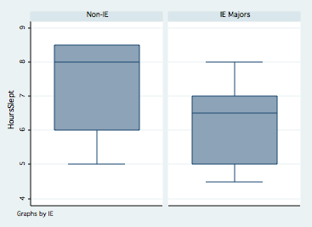

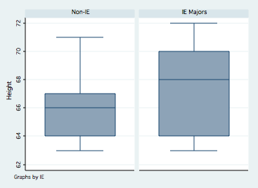

Stem-and-leaf plot for HoursSlept

4* | 5
5* | 005
6* | 055
7* | 000
8* | 000555

