Example A: Whiskey prices

Monopoly States: Private-ownership states:

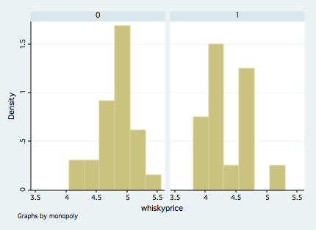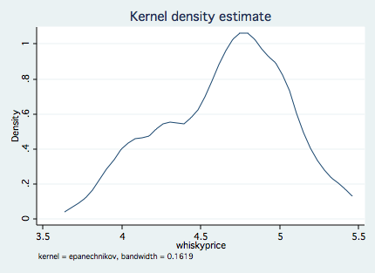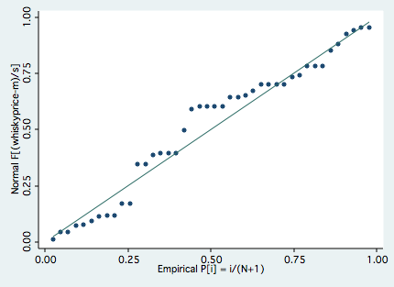

F-max test for equal variances: p-value = 0.2385

Two-sample t test with equal variances
------------------------------------------------------------------------------
Group | Obs Mean Std. Err. Std. Dev. [95% Conf. Interval]
---------+--------------------------------------------------------------------
0 | 26 4.838462 .0518598 .2644344 4.731654 4.945269
1 | 16 4.34625 .0859403 .3437611 4.163073 4.529427
---------+--------------------------------------------------------------------
combined | 42 4.650952 .0586351 .3799988 4.532536 4.769368
---------+--------------------------------------------------------------------
diff | .4922115 .0942678 .3016892 .6827338
------------------------------------------------------------------------------
diff = mean(0) - mean(1) t = 5.2214
Ho: diff = 0 degrees of freedom = 40

Ha: diff < 0 Ha: diff != 0 Ha: diff > 0
Pr(T < t) = 1.0000 Pr(|T| > |t|) = 0.0000 Pr(T > t) = 0.0000

Two-sample t test with unequal variances
------------------------------------------------------------------------------
Group | Obs Mean Std. Err. Std. Dev. [95% Conf. Interval]
---------+--------------------------------------------------------------------
0 | 26 4.838462 .0518598 .2644344 4.731654 4.945269
1 | 16 4.34625 .0859403 .3437611 4.163073 4.529427
---------+--------------------------------------------------------------------
combined | 42 4.650952 .0586351 .3799988 4.532536 4.769368
---------+--------------------------------------------------------------------
diff | .4922115 .1003752 .2858315 .6985915
------------------------------------------------------------------------------
diff = mean(0) - mean(1) t = 4.9037
Ho: diff = 0 Satterthwaite's degrees of freedom = 25.8561

Ha: diff < 0 Ha: diff != 0 Ha: diff > 0
Pr(T < t) = 1.0000 Pr(|T| > |t|) = 0.0000 Pr(T > t) = 0.0000

Example B: Time needed for 15 teens to send “The quick brown fox jumps over the lazy dog” via SMS
Own Phone | Control Phone | (difference)
37.6 | 58.8 | -21.2
54.87 | 72.96 | -18.09
27.27 | 37.19 | -9.92
65.58 | 68.2 | -2.62
38.35 | 41.02 | -2.67
35.65 | 42.18 | -6.53
38.6 | 53.8 | -15.2
50 | 61.94 | -11.94
21.2 | 31.8 | -10.6
36.55 | 62 | -25.45
43.96 | 91.1 | -47.14
39.17 | 44.82 | -5.65
57.31 | 56.31 | 1
30 | 61.25 | -31.25
42.3 | 51.11 | -8.81

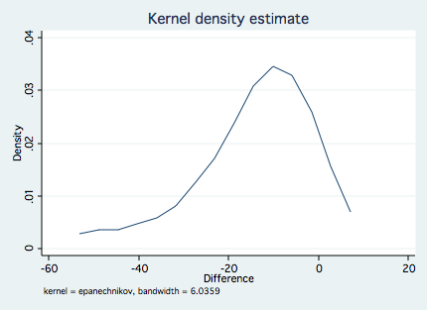

One-sample t test
------------------------------------------------------------------------------
Variable | Obs Mean Std. Err. Std. Dev. [95% Conf. Interval]
---------+--------------------------------------------------------------------
Differ~e | 15 -14.40467 3.282173 12.7118 -21.44423 -7.365105
------------------------------------------------------------------------------
mean = mean(Difference) t = -4.3888
Ho: mean = 0 degrees of freedom = 14

Ha: mean < 0 Ha: mean != 0 Ha: mean > 0
Pr(T < t) = 0.0003 Pr(|T| > |t|) = 0.0006 Pr(T > t) = 0.9997

Sign test: Observed 14 –‘s and 1 +. P(1 or fewer +’s | the null hypothesis is true) = __________________

Alpha, beta, power, p-value, standard error, null hypothesis, confidence interval,

